# PEAD ANALYSIS REPORT

# Background:

Post earnings announcement drift (PEAD) is one of the most popular alphas generating anomalous anomalies according to the literature which prescribes buying portfolio of firms that release extremely positive earnings news and selling those with the negative earnings news. According to the literature, PEAD is dependent on multiple factors such as standardized unexpected earnings (SUE), yearly/quarterly change in SUE, yearly/quarterly change in revenue, institutional investor ownership, ex-ante earnings announcement volatility, which is calculated through implied risk in options, etc. But the most famous variable is SUE on which the drift is dependent, and other variables/information are further used to see the magnitude of drift with respect to other information available.

Research Paper References:

1. [Do institutional investors exploit the post-earnings announcement drift](https://papers.ssrn.com/sol3/papers.cfm?abstract_id=446520)
2. [Post-earnings-announcement drift in global markets: Evidence from an information shock](https://papers.ssrn.com/sol3/papers.cfm?abstract_id=2269909)
3. [Herding on earnings news: The role of institutional investors in post–earnings-announcement drift](https://papers.ssrn.com/sol3/papers.cfm?abstract_id=2912670)

# Underlying Logic:

1. Institutions Reaction: Investment firms increase their holding in top decile firms as the reported numbers are higher than expected and liquidate/short bottom decile firms due to poor performance based on market expectations.
2. Information Asymmetry: Not all investors react to earnings at the same time, leading to a lag in reaction that causes a gradual adjustment in stock prices, contributing to the drift.
3. Large Volume: Institutional investors often trade in large volumes, which can take time to execute without significantly impacting the stock price, resulting in abnormal drift in the long term (for 60 days).
4. Wait for Information: Investors might wait for further information to strengthen their beliefs, such as waiting for analysts reports, economic indicators, market sentiments, etc.

# Assumptions:

For our analysis, we primarily focused on SUE across all significant markets across the globe. There are some key assumptions that we used, in line with various literatures, which are testing for top decile and bottom decile of firms that lie in the highest and lowest SUE groups, considering a period of 60 trading days following the announcement date (t) + 3 days, even helping to eliminate an abrupt jump due to earnings impact, taking active days for the testing period and winsorizing daily returns at 0.5%. To get deeper insights, we analysed data on different percentiles, markets, liquidity, and two strategies.

# Approach:

We conduct our analysis in a systematic manner, and all tasks and testing are listed below for a more detailed explanation.

* 1. Testing of monthly excess returns over market returns across different markets (Approach 1: Strategy is developed by comparing standardised unexpected earnings of a current event with respect to all events in the past quarter)
     + Based on Decile
     + Based on Quintile
  2. Graphical representation of cumulative returns of different markets for top and bottom decile based on approach 1
  3. Graphical representation of global cumulative returns for top and bottom decile with 5 year interval based on approach 1
  4. Testing of monthly excess returns over market returns pre and post starting 2010 across different markets based on approach 1
  5. Testing of monthly excess returns over market returns across different markets based on liquidity and approach 1.
     + For each market, firms are grouped by years and filtered into high and low segments based on market capitalization and shares outstanding and then selection process is as follows:
       1. High Liquidity Companies: Firms that are in the high segment for both market capitalization and shares outstanding.
       2. Mid Liquidity Companies: Firms that are in the high segment for either market capitalization or shares outstanding, but not both.
       3. Low Liquidity Companies: Firms that are in the low segment for both market capitalization and shares outstanding
  6. Testing of monthly excess returns over market returns across different markets based on alternate approach 2 which is different from initial approach 1 (approach 2: Strategy is developed by comparing standardised unexpected earnings of a current event with respect to all events in the past one month before the the event date)

1. Testing of monthly excess returns over market returns across different markets based on Approach 1

Analysis

* Overall, by taking positions in all markets, the global excess returns are -0.78 and 0.41 in case of the bottom 10% and top 10% firms filtered on SUE and the returns are -0.62 and 0.33 in case of bottom 20% and top 20% firms.
* By shorting the bottom 20% firms across different markets rather than 10% firms, the portfolio risk decreases by 22% and similarly by 9% longing the top 20% firms. But there is a dip in the sharpe ratio because of the dip in excess returns, primarily at the 2nd and 9th decile levels.
* Approximate numbers of events vary a lot country wise hence it is crucial to look for specific markets along with all markets. The total percentage of event data for the US, Canada, Japan, and India are 63.5%, 8%, 6%, and 4%, summing up to 81.5% of total data.
  1. Based on Decile

Table1 - Excess Returns

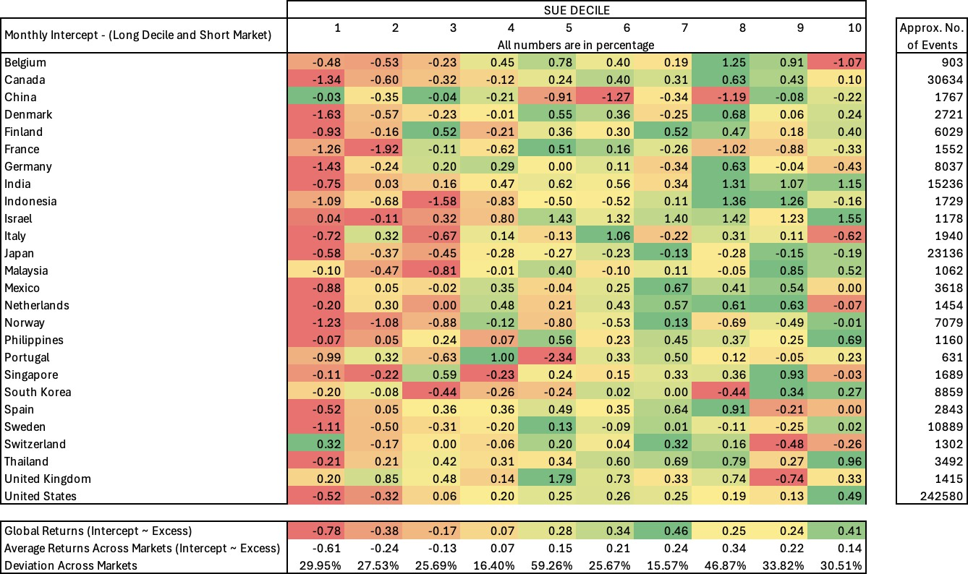

Table 2 - Sharpe Ratio

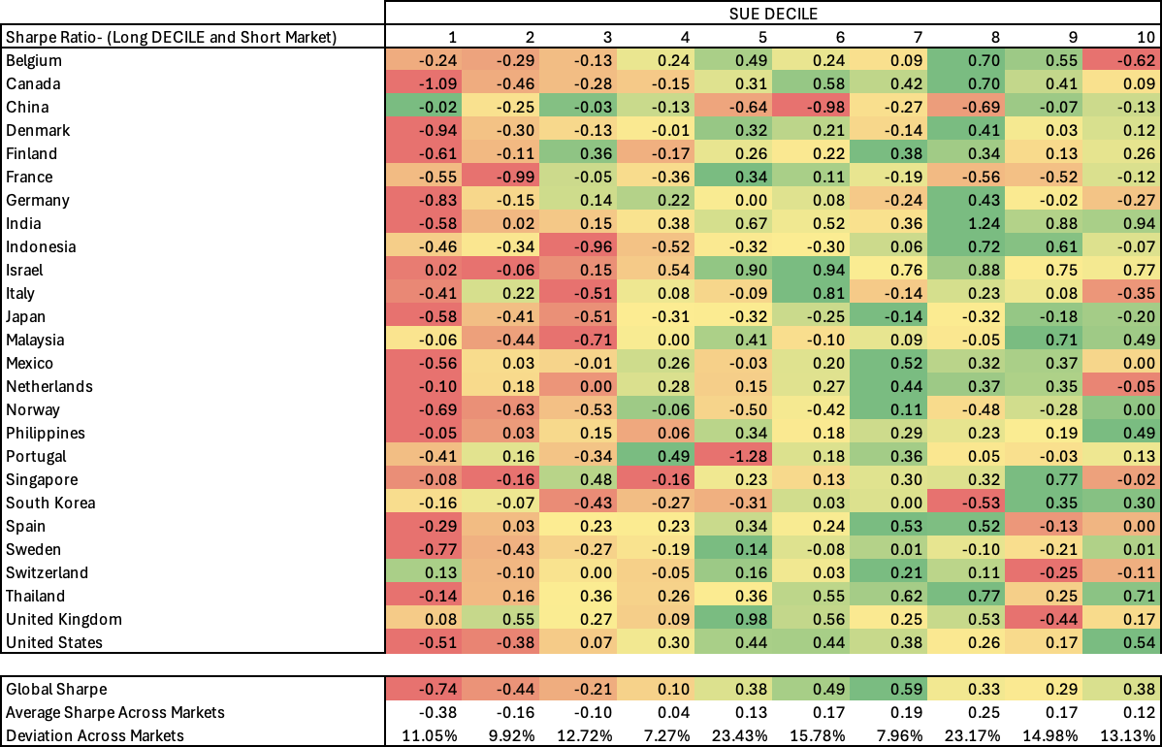

* 1. Based on Quintile

Table 3 - Excess Returns

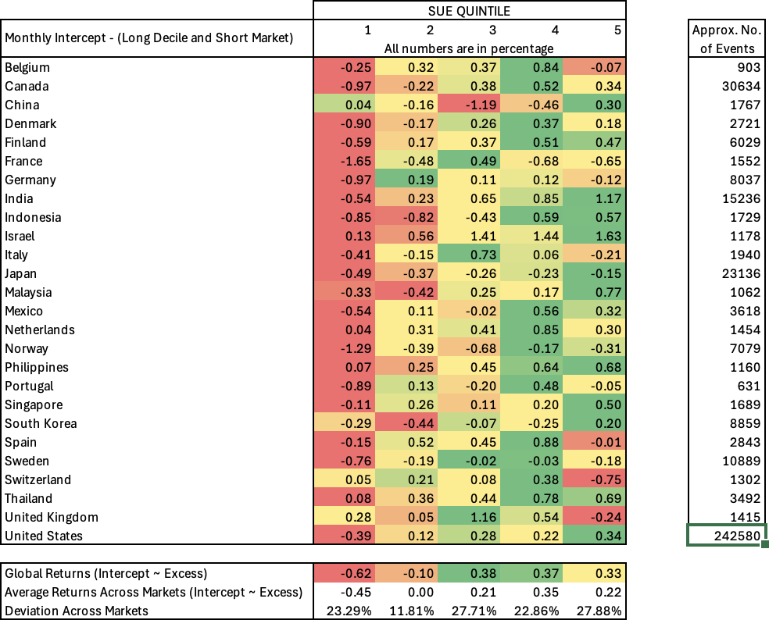

Table 4 - Sharpe Ratio

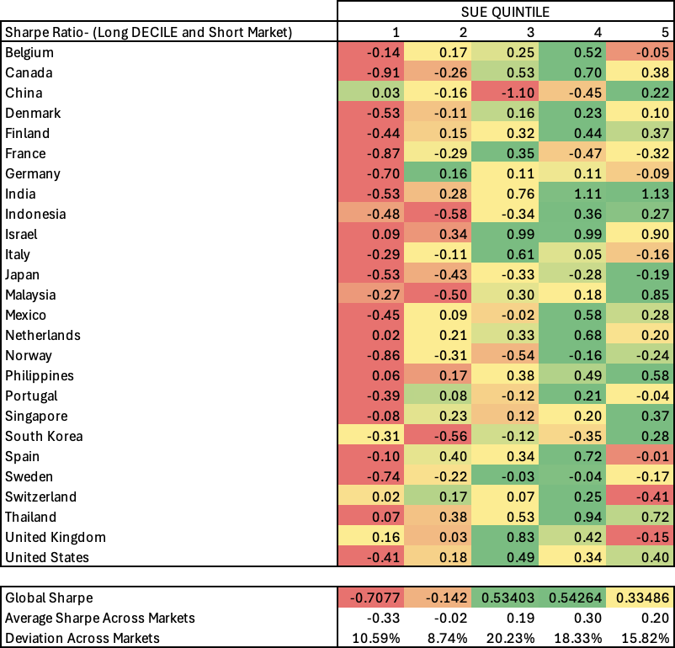

1. Graphical representation of cumulative returns of different markets for top and bottom decile based on approach 1

Analysis

* By visual analysis, in the case of top 10% firms, excess returns are positive for 11 countries, neutral for 9 countries, and negative for 6 countries (the ideal case should be positive for all countries). And in the case of bottom 10% firms, excess returns are positive for 1 country, neutral for 5 countries, and negative for 20 countries (the ideal case should be negative for all countries).
* This shows an existence of more drift on the bottom 10% across different markets in comparison to the top 10% firms.

# Figure 1 - Top Decile

**Figure 2 - Bottom Decile**

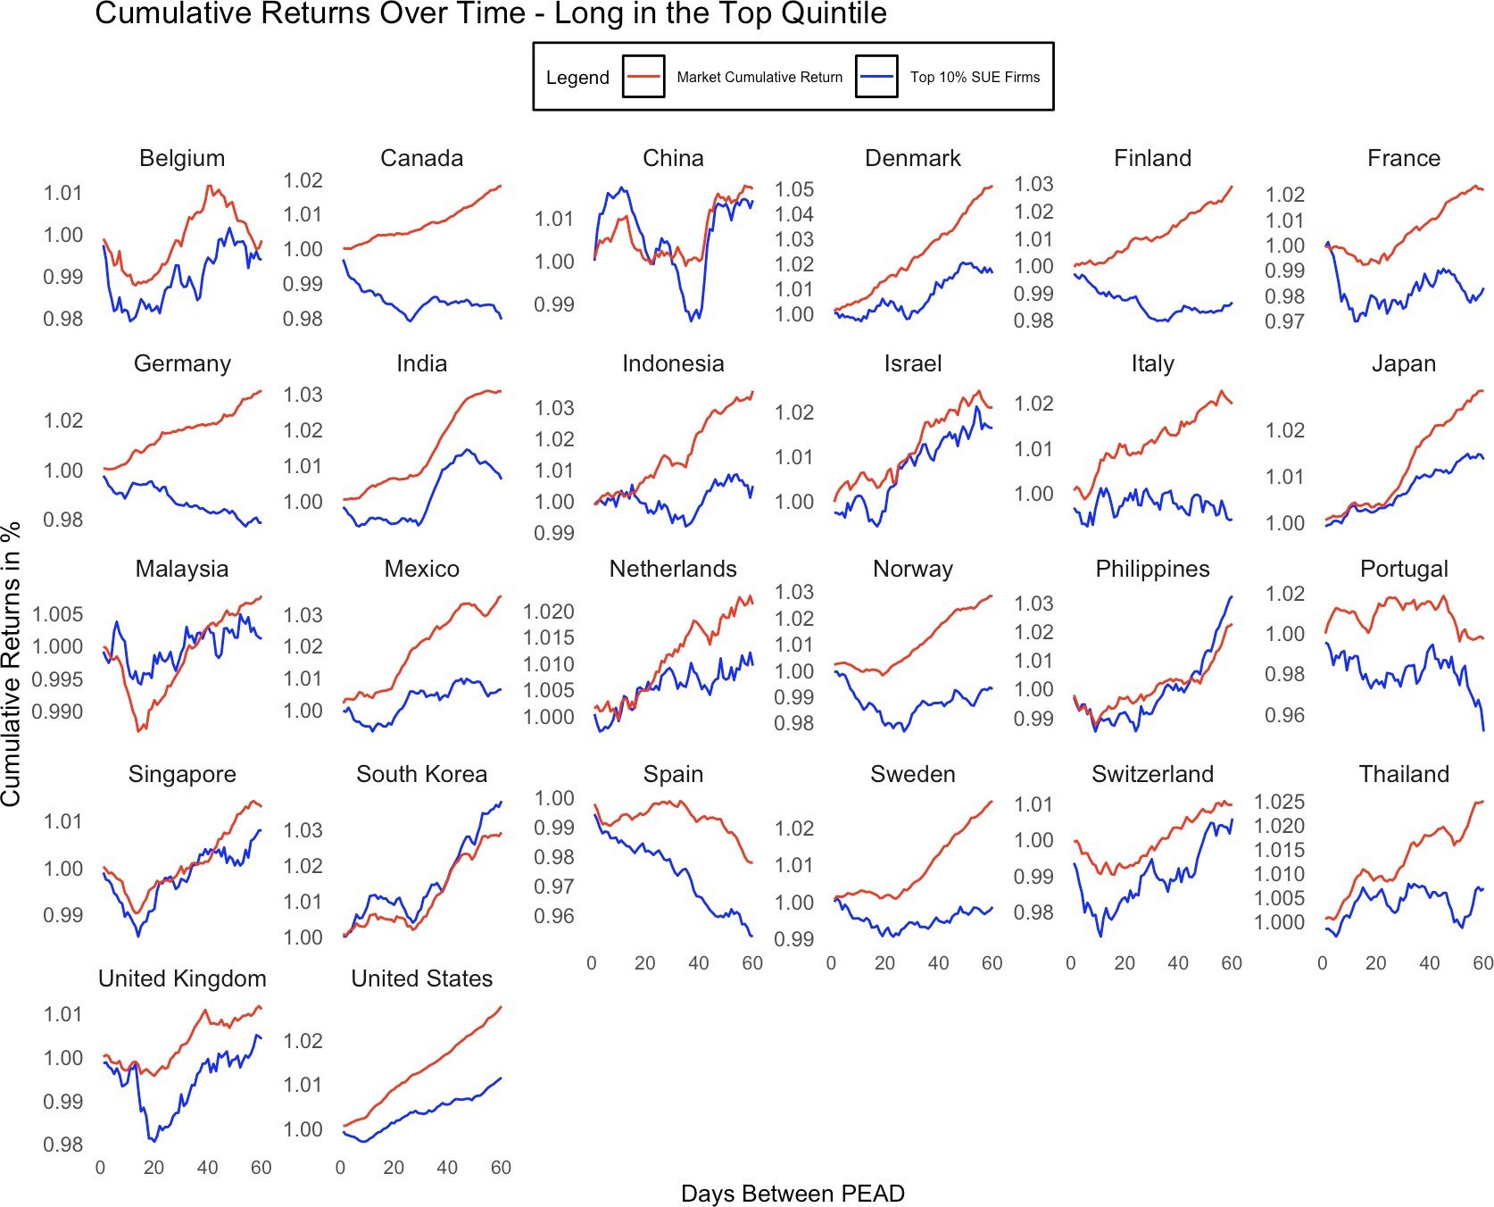

1. Graphical representation of global cumulative returns for top and bottom decile with 5 year interval based on approach 1

Analysis

* The drift reacts differently across different time periods from 2000 start to 2023 end. The drift decreases significantly for the top 10% firms for graphs 1 to 5 in figure 3, but the scenario completely changes for bottom 10% firms. The drift increases leading to higher negative returns.
* With the graph, it is easy to conclude that the PEAD exists. But the dominating effect on returns shifts gradually from top decile to bottom decile across testing period.

# Figure 3 - Top Decile

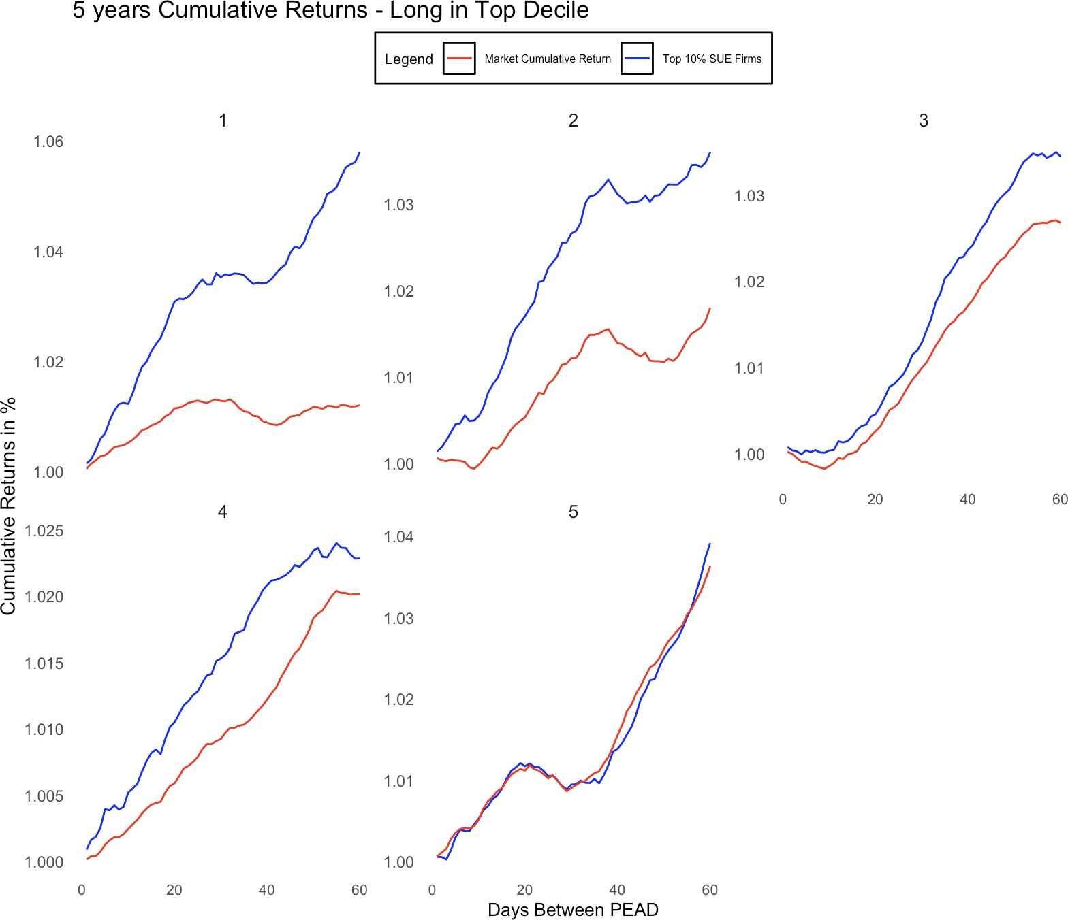

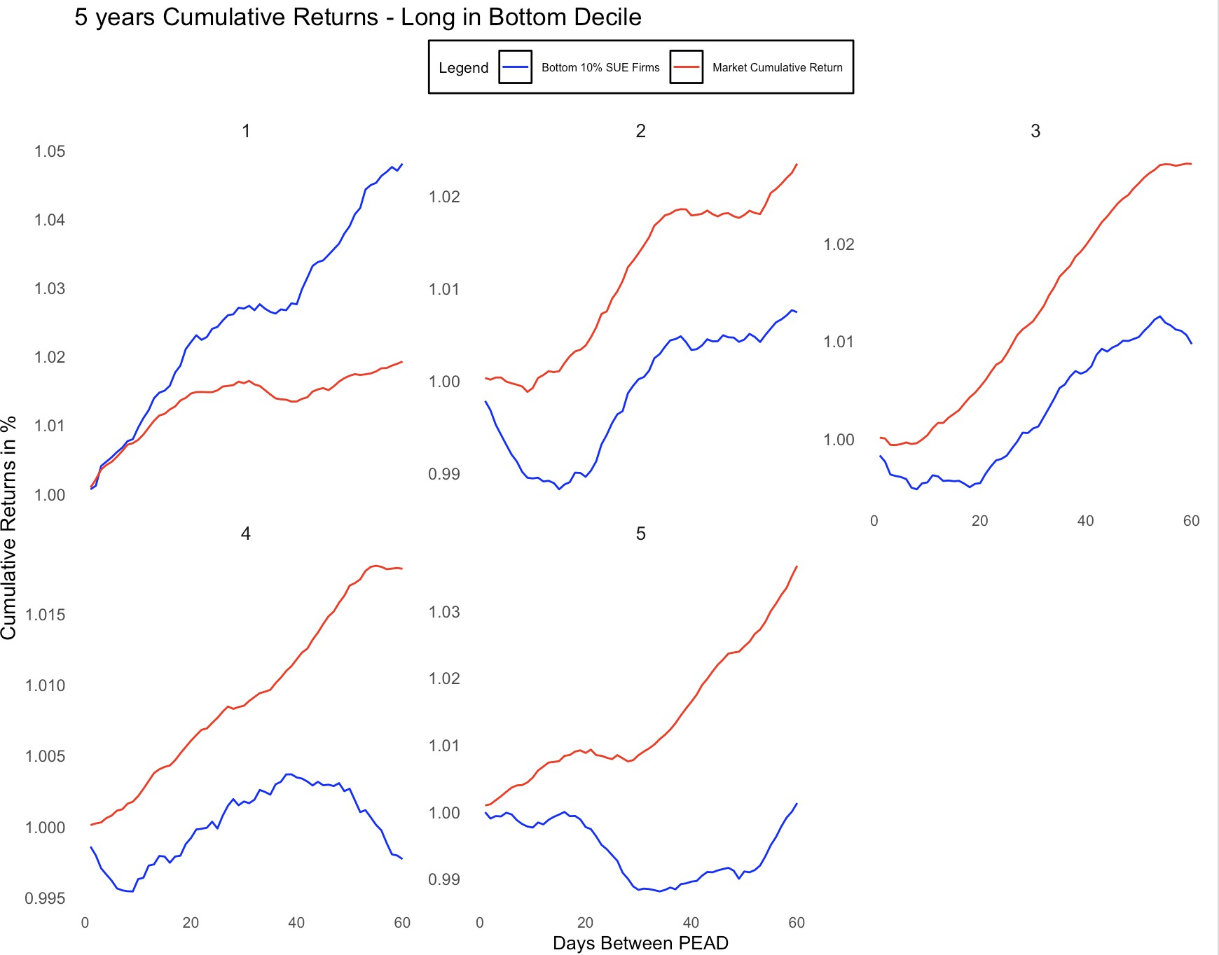**Figure 4 - Bottom Decile**

1. Testing of monthly excess returns over market returns pre and post 2010 start across different markets based on approach 1

Analysis

- Overall, by taking positions in all markets, the global excess returns are -0.21 and 0.97 in the case of bottom 10% and top 10% firms filtered on SUE and the returns are -1.22 and 0.01 in the case of bottom 20% and top 20% firms. Moreover, the results here support the conclusion drawn in section 4.

Table 5 - Pre 2010 Start: Excess Returns

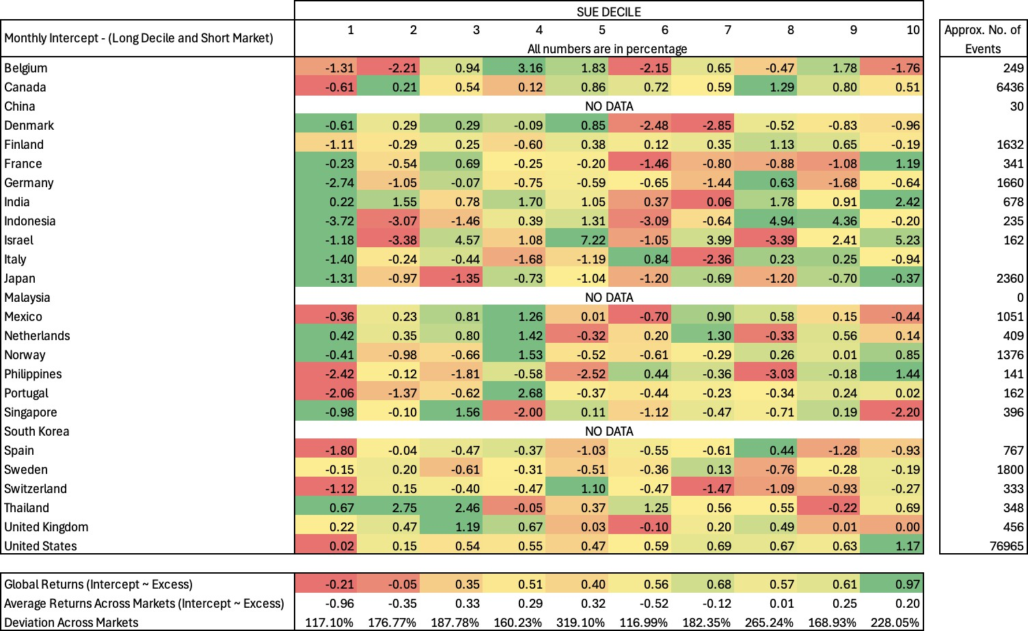

Table 6 - Post 2010 Start: Excess Returns

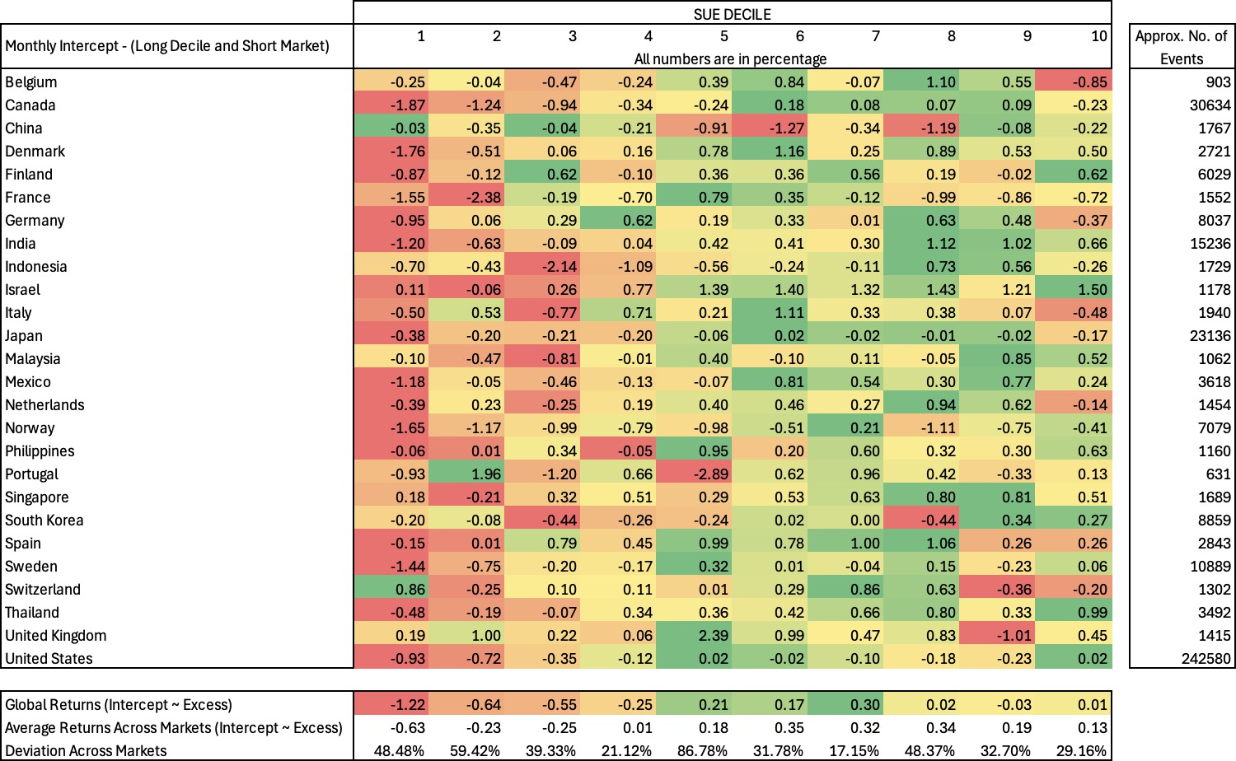

1. Testing of monthly excess returns over market returns across different markets based on liquidity and approach 1

Analysis

* There are studies that say the existence of PEAD more prevalent in low liquidity firms in comparison to high liquidity firms, which results in higher transaction costs and wiping out actual PEAD in the case of low liquidity firms. Our test further approves the above results, shown in the below table:

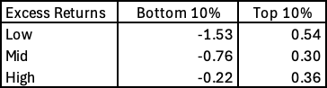

* Even not the returns but also the volatility across different markets decreases from low liquid firms to high liquid firms.

* 1. High Liquidity

Table 7: Excess Returns

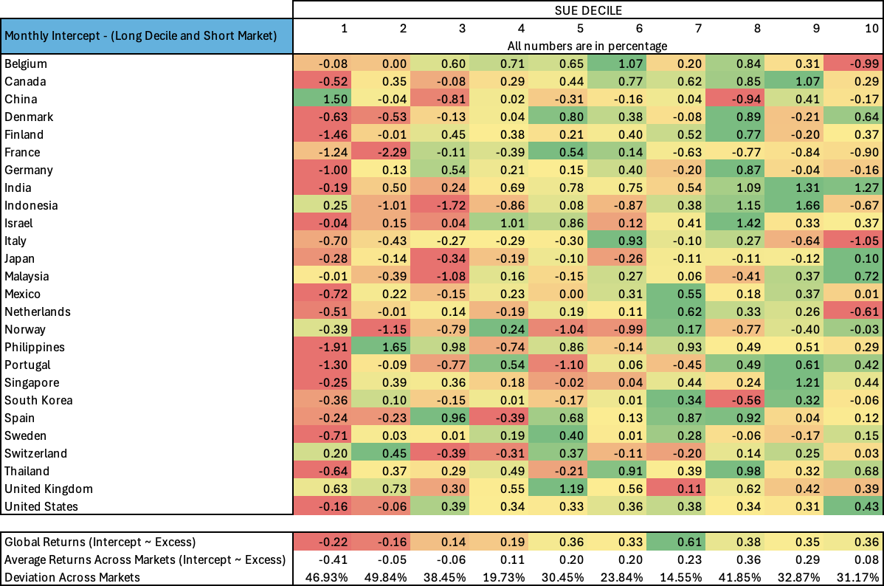

Table 8: Sharpe Ratio

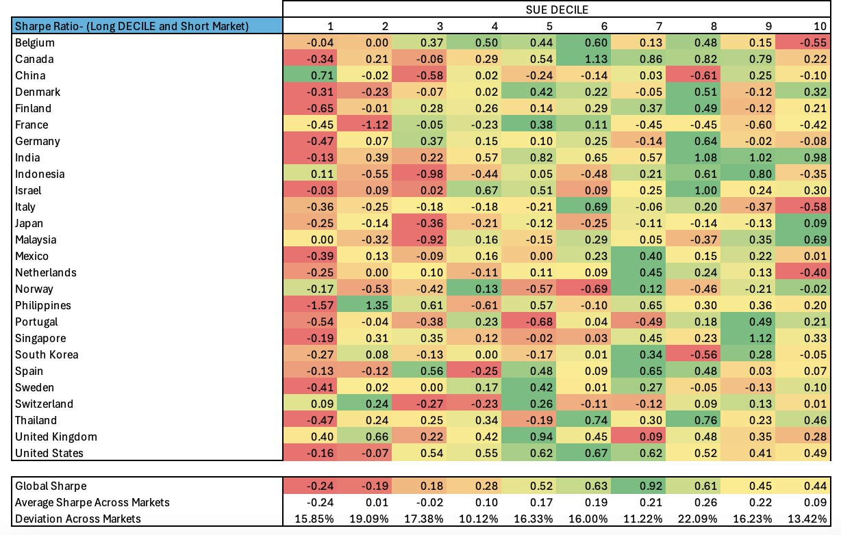

* 1. Mid Liquidity

Table 9: Excess Returns

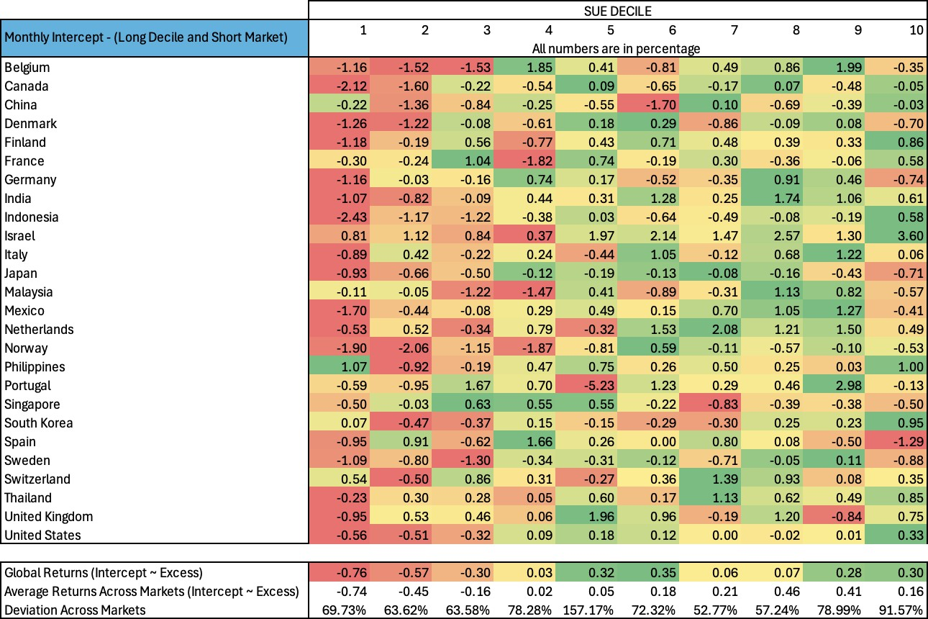

Table 10: Sharpe Ratio

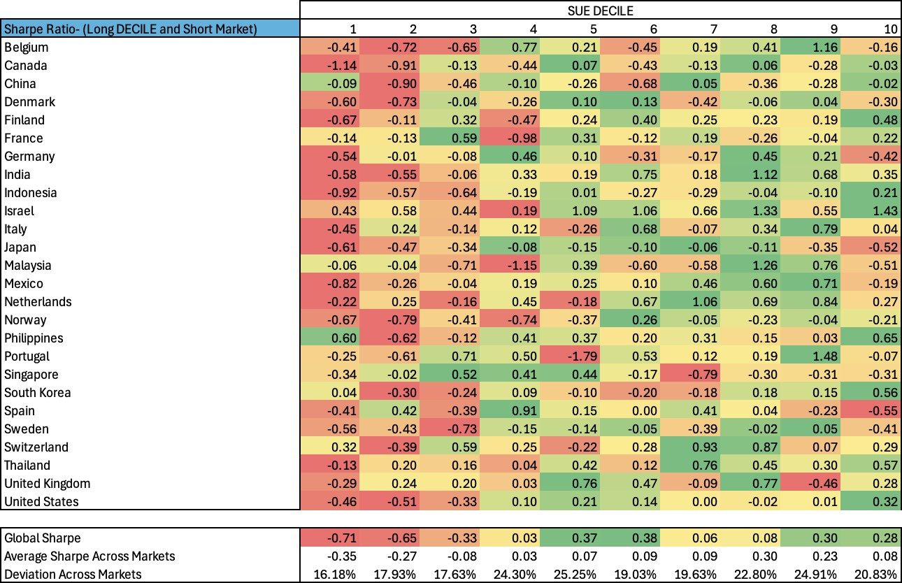

* 1. Low Liquidity

Table 11: Excess Returns

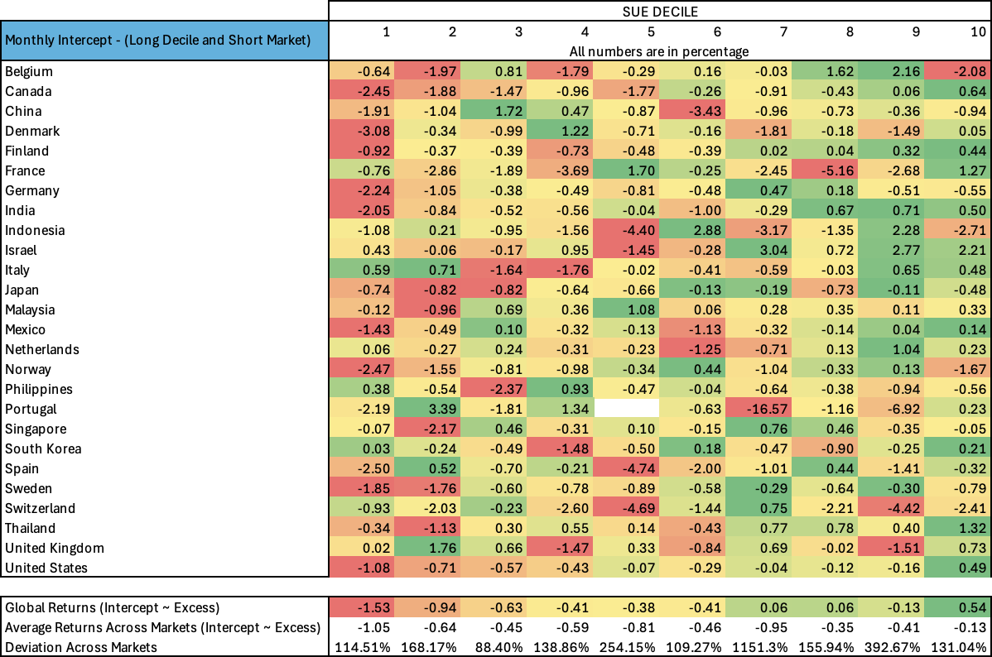

Table 11: Sharpe Ratio

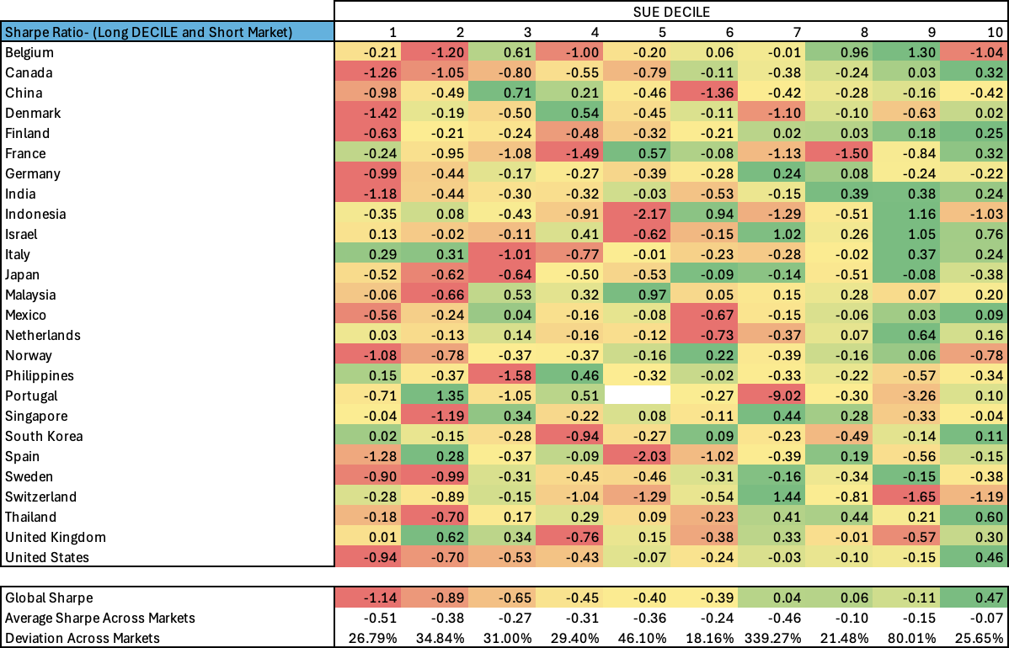

1. Testing of monthly excess returns over market returns across different markets based on alternate approach 2 which is different from initial approach 1

Analysis

* The purpose of the test is to check how recent earnings in the past month impacted the initial strategy. The idea behind is that sentiments might play an important role in segmenting companies.
* Overall, by taking positions in all markets, the global excess returns are -1.01 and 0.01 in case of bottom 10% and top 10% firms filtered on SUE. The returns of 5 dominant markets – US, Canada, Japan, and India are further analysed to inspect the changes. The results don’t give any reasonable understanding behind the numbers, but returns do not act differently in strategy 1 and strategy 2 which makes sense as the lag period while filtering is from 2-3 months.

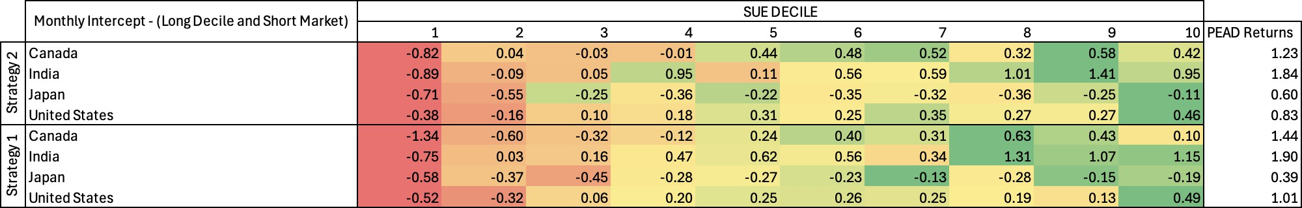

Table 13: Excess Returns

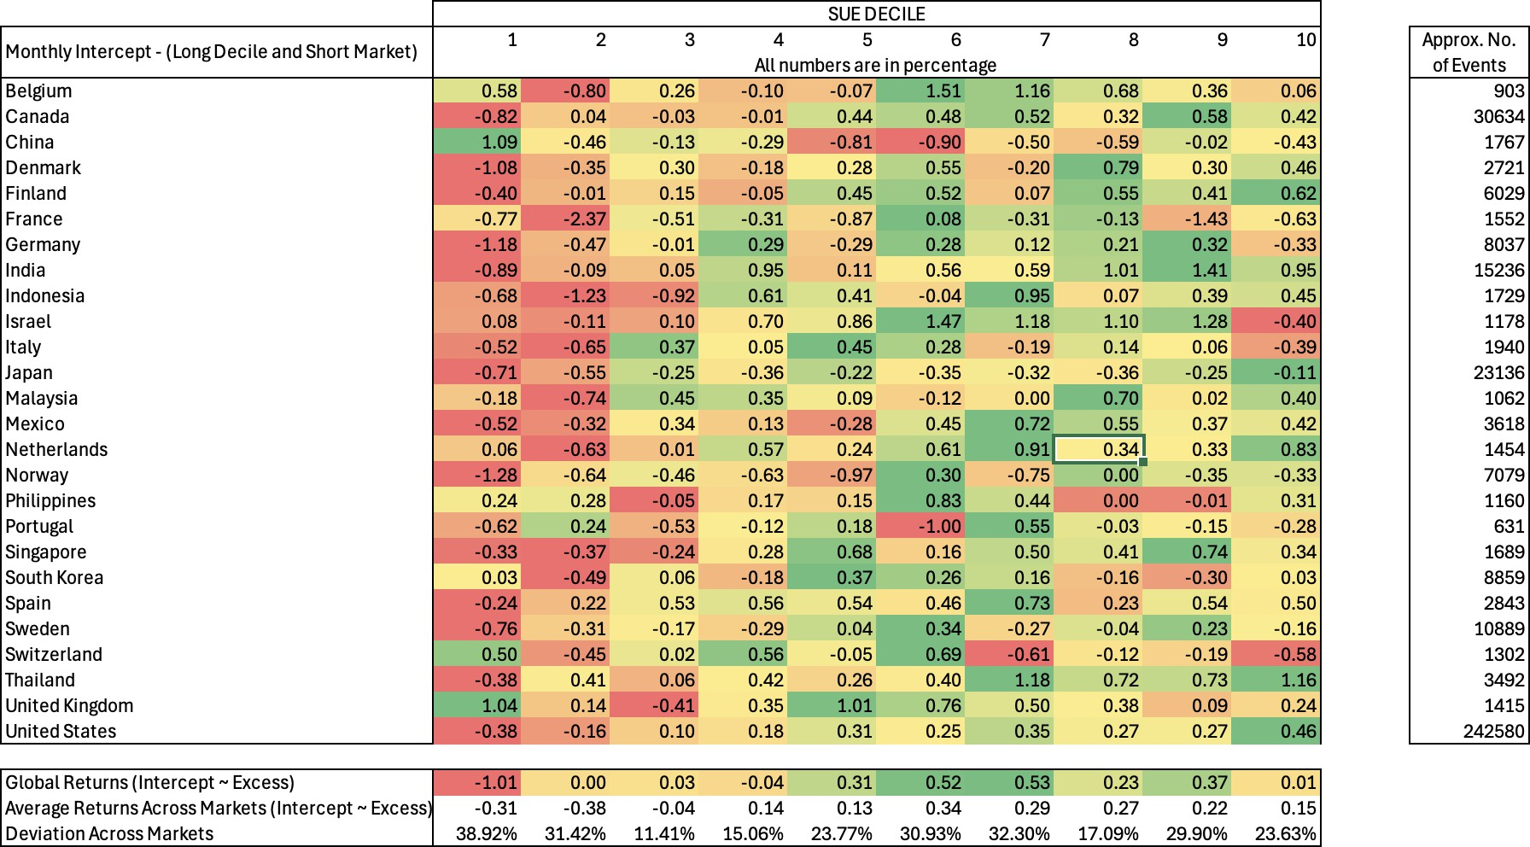

Table 14: Sharpe Ra